Gandhinagar Institute of Technology
A Report on
“Sensitization Program”
(29 January 2021)
Event Overview:
The webinar on “Sensitization Program” was organized on 29th January 2021 at Gandhinagar Institute of Technology by SSIP, IPR & IIC Cell. The session was organized for the students of Bachelor of Engineering 1st year with the permission of Dr H N Shah, Director. The seminar was organized to provide exposure innovation, IPR & IIC.
Objective:
The objective of the session was to share the information regarding the startup activities at the institute, the benefits of SSIP, IPR, IIC etc. The silent objective was also to educate them about need of startup in the current situation.
Program Overview:
There were 51 students participated in the session. The session started at 2:00 pm through Google Meet. Prof Mrugesh Khatri has initiated the session with the definition of startup. He added that the current competitive market needs technological advancements in the current product to sustain in the market. The disruptions are the essential in making human life easier. The activities of institute under SSIP was shared with the students. The participants were informed how they can leverage maximum benefit of the SSIP.
In the next session, Prof Jyotin kateshia informed about the importance of intellectual property rights in engineering. He initiated a session with different IP rights in India and discussed patent, copyright, trademark, geographic Indication, design, and integrated circuit patent. He stated that patents must content novelty, innovation, and industrial application. He also showed various case studies over the patent. He concluded his session by stating the condition in which patent not granted.
In the final session, Prof. Sejal Bhavsar had covered various objectives of the Institute's of Innovation council cell. The students were motivated regarding importance of Innovation, examples of Innovations, toycathon event and procedure of IIC cell. Many students actively participated in the session and enthusiastically joined session for collaborating in the success path to become Innovator and entrepreneur in the current era.
The event was a grand success under the enlightenment of Dr H N Shah, Director of the institute and the participants.
Photo Gallery:

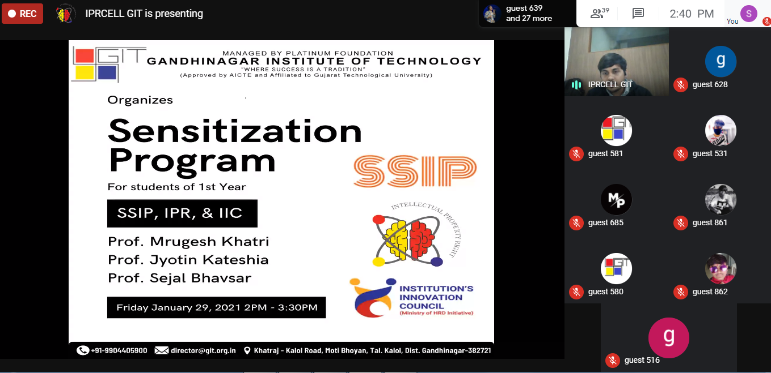
Initiation of the webinar

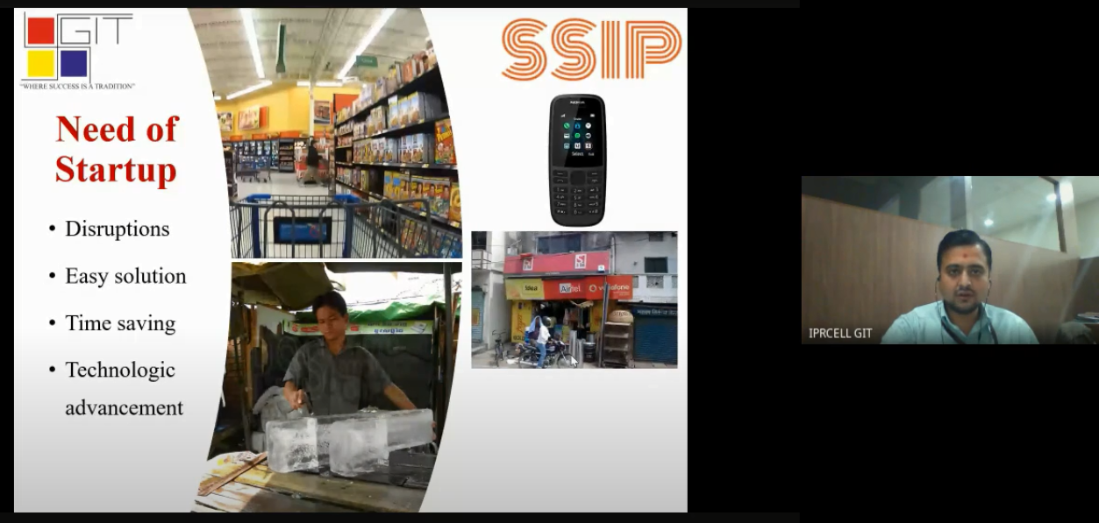
Prof Mrugesh Khatri sharing information about SSIP

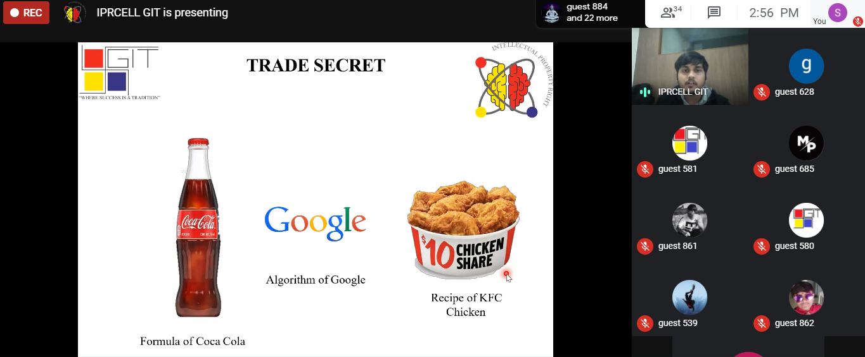
Prof Jyotin A Kateshia sharing information about IPR

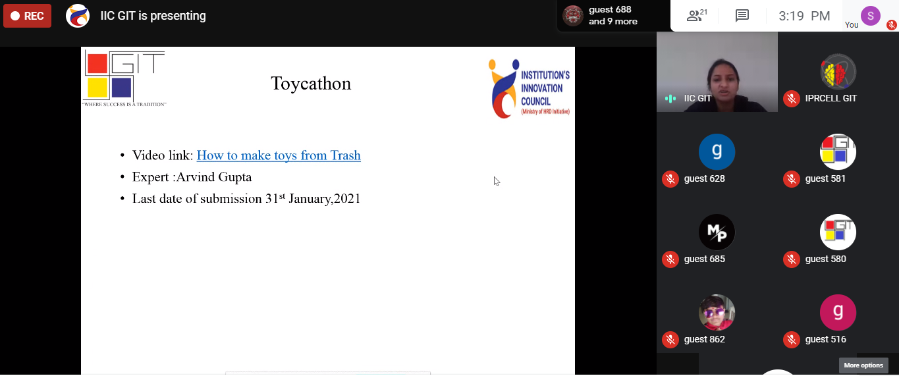
Prof Sejal Bhavsar sharing infromation about IIC

