Gandhinagar Institute of Technology
A Report on
“Drug Abuse and Fitness Awareness Programme”
05th March 2021

Introduction:
The Healthy Campus Committee (HCC) of Gandhinagar Institute of Technology regularly organizes activities pertaining to the Healthy Campus initiative. The initiative has identified seven key areas: Healthy Living, Social Consciousness, Stress Management, Building Self Esteem, Developing Critical Thinking, Developing Soft Skills and leading a Drug Free Life. With this motivation the HCC Committee organized their flagship event called “Drug Abuse and Fitness Awareness Programme” on 05/03/2021 (Friday) in collaboration with "Narcotics Control Bureau, Ahmedabad (MHA, GoI)” and "High on Life Foundation". Director sir, Dr H N Shah was instrumental in planning and execution of the webinar. HCC committee acknowledges the support of all Trustees and the Management in providing the necessary infrastructure and resources for conducting the event successfully. The webinar was coordinated by Prof. Jatin Chakravarti (HCC Coordinator, EC) under the guidance of Director Sir.

Objective:
According to the report published in India Times, almost 74% Indian homes have one member, an adult who is a drug addict. As per a report compiled by ECI (Election Commission of India) on May 24, Gujarat ranked the highest when it came to the value of seized drugs, which amounted to Rs 524.35 Crore. According to the National Institute on Drug Abuse (NIDA), by the time individuals reach their senior year of high school, 70 percent will have tried alcohol, 50 percent will have abused an illicit drug, 40 percent will have smoked a cigarette, and 20 percent will have used a prescription drug recreationally, or for nonmedical purposes. The objective of this event was to stop youngsters from getting addicted to drugs and motivate them to adapt fitness as a lifestyle. The programme also aimed at physical and mental fitness of the students. It stressed upon physical activities, workouts, outdoor sports and the nutritional intake of the students.

Program Overview:
In morning session events like “Graffiti”, “5Km Run for Fight Against Drug Abuse” and “Critical Thinking” were organized. Graffiti event was coordinated by HCC faculty members Prof. Dhaval Panchal (ME) and Prof. Maitri Patel (CE). In this event the participants express the underlying social and political burning issues and a whole genre of artistic expression using sketches and paintings. Participants submitted digital paintings created using illustration software/apps like Adobe Photoshop, CorelDRAW, Adobe Illustrator, Microsoft Paint, Procreate and online graphic design editor like Canva. Participants were allowed to use Copyright Free Images that were downloaded from popular online sources such as Canva, Pexels, Unsplash and Pixabay. The digital art competition had a wide range of topics such as ‘Drug Abuse’, 'Narcotics', 'Fitness', 'Healthy Living', 'Yoga', 'Meditation', 'Cultural Heritage', 'Climate Change', 'Global Warming', 'Covid-19', 'Natural Disasters (Australia wildfires)', etc. Winner and Runner-Up of Graffiti event were Prajapati Nimesh Somrajbhai (180120107134, CE, Sem. 6) and Dhruv A. Siddhpura (200120106011, CL, Sem. 1), respectively. “5Km Run for Fight Against Drug Abuse” event was coordinated by HCC faculty members Prof. Swapnil Panchal (IT) and Prof. Rahish Silavat (EE). Running is one of the few exercises that can be done anywhere and doesn’t require an expensive gym membership. One doesn’t have to be a seasoned athlete to participate. In these COVID-19 times, a running event can act as an immune-boosting, self-quarantining, social distancing, sanity-saving pandemic routine. Participants can run, jog, or walk anytime and anywhere with proper social distancing guidelines. For tracking their distance and time, participants installed the “Nike Run Club” app on their Android/iOS phones and submitted their running details to the coordinators through Google Form. Critical Thinking event was coordinated by HCC faculty members Dr. Nehal Shah (MBA) and Prof. Juhil Kapatel (CL). Critical Thinking was designed with an objective to empower students to represent their ideas. It enabled students to analyze problems that we face in our society and day-to-day life at the same time improve their elocution skills. Topic for the competition were related to Social and General Awareness, Healthy Living, Drug Abuse, Covid-19 & other contemporary issues. The event was judged by Dr. Milan Shah (HOD, MBA) and Dr. Sneha Patel (MH). Winner and Runner-Up of the Critical Thinking event were Shah Mohil Srujalkumar (180123106012, CL, Sem. 8) and Valand Maulik Arvindkumar (207150592002, MBA, Sem. 1), respectively.

Shri Shailendra Kumar Mishra (Zonal Director, Narcotics Control Bureau, MHA, GoI) was the chief guest for the programme. He attended the online Critical Thinking event wherein he explained the role of the NCB and today's youth in the fight against drug abuse. It was an interactive session wherein the students asked their queries regarding drugs and other psychotropic substances. He praised the HCC committee for organizing innovative online events for students such as a 5Km run. The HCC committee also ran an innovative pre-event video campaign wherein Dr H N Shah (Director, GIT), and the dignitaries Shri Shailendra Kumar Mishra (NCB) and Shri Sagar Brahmbhatt (Founder, High on Life Foundation) spread awareness about drug abuse and motivated students to adapt fitness as a lifestyle. All the students, faculties and dignitaries pledged to stay healthy and lead a drug free life. The event concluded with a Vote Of Thanks from Prof Jatin Chakravarti (Coordinator, HCC). The active participation of faculty members and student participants contributed to the magnificent success of the programme.

Photo Gallery:
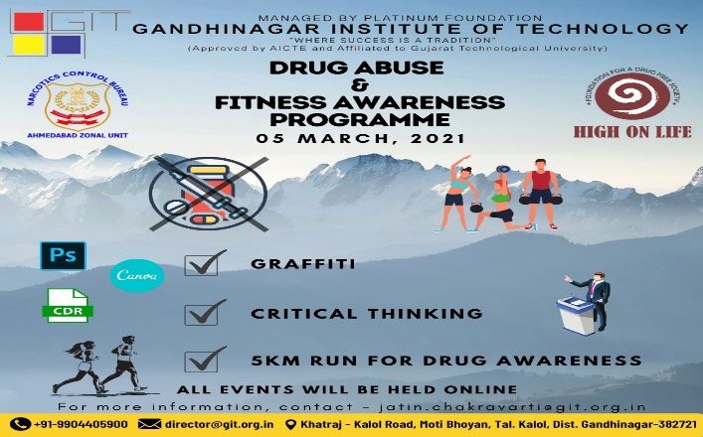 | 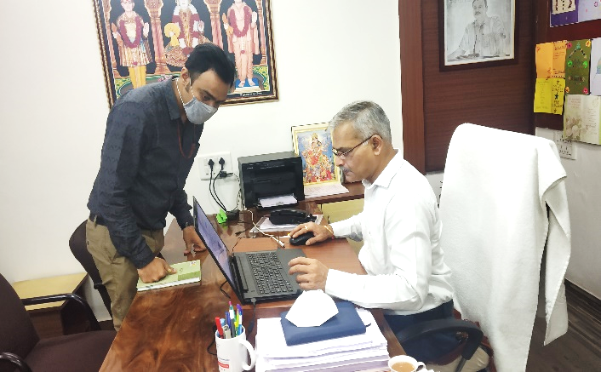
Event Banner | Dr H N Shah and Prof. Jatin Chakravarti during the planning of the event.
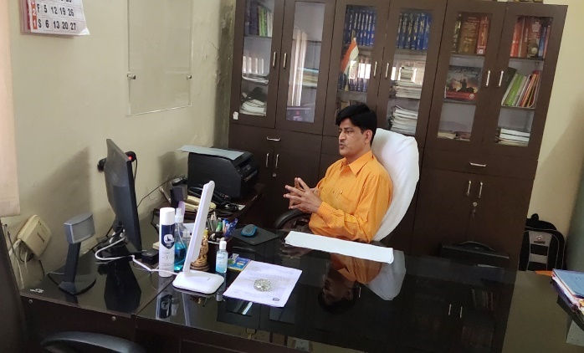 | 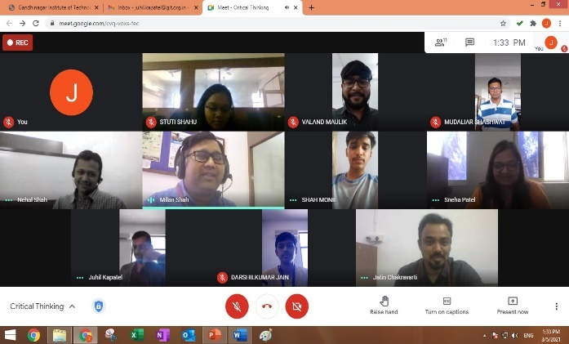
Shri Shailendra Kumar Mishra (Zonal Director, NCB) during the online session. | Participants, judges and event coordinators during the Critical Thinking event.
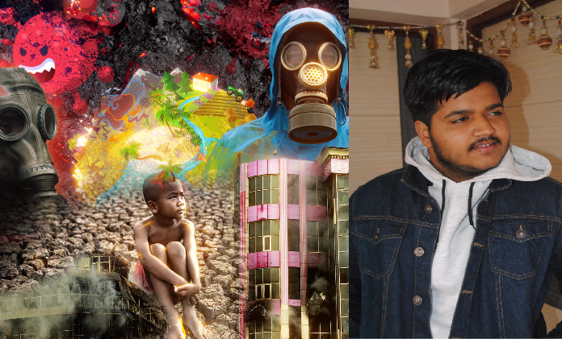 | 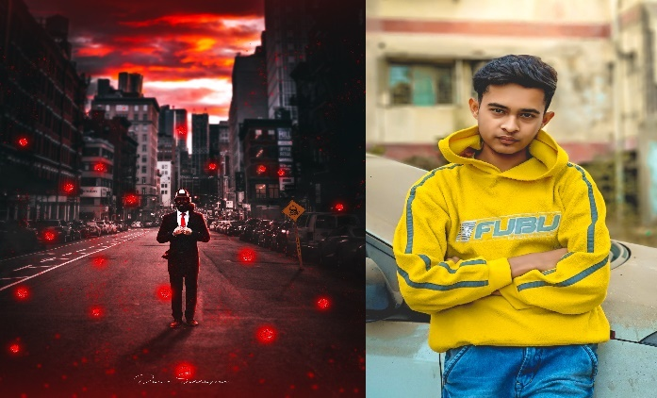
Winner of Graffiti Event: Prajapati Nimesh Somrajbhai (Theme - Natural Disaster) | Runner-Up of Graffiti Event: Dhruv A. Siddhpura (Theme - Covid-19)
 | 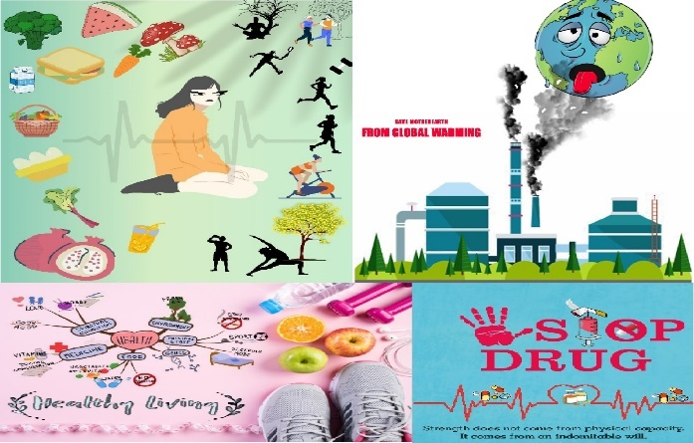
Participant editing his Digital art using Canva Software during Graffiti event | Graffiti online entries with different themes submitted by participants
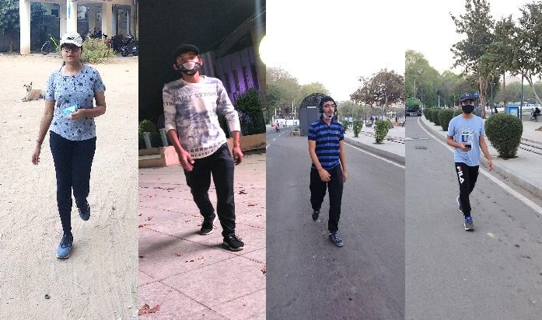 | 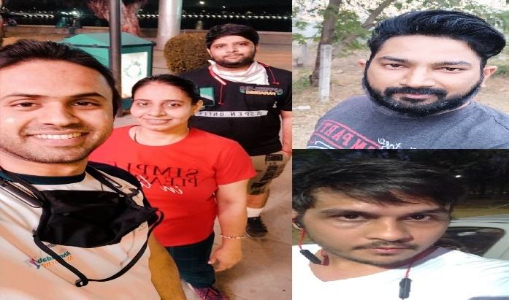
Student participants during the “5Km Run for Fight Against Drug Abuse” event | Faculty participants during the “5Km Run for Fight Against Drug Abuse” event
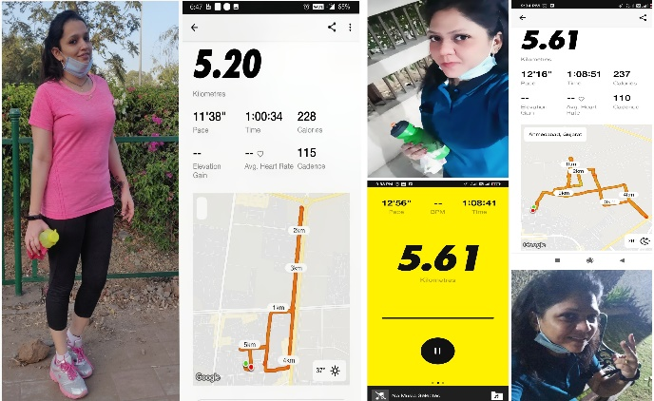 | 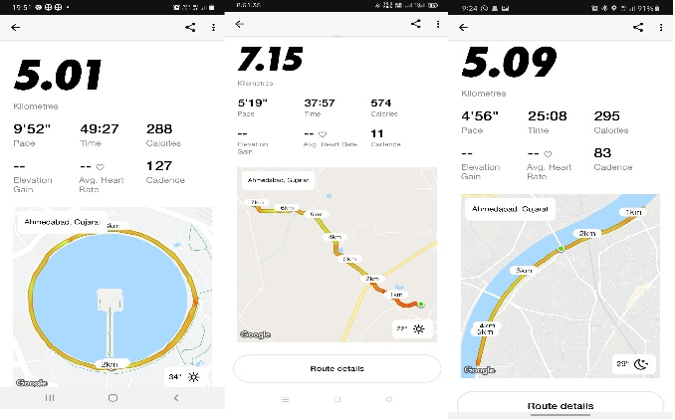
Prof. Sumedha Mahajan and Prof. Pooja Patanwal with their running details on “Nike Run Club” app | “Nike Run Club” app’s running and track details of different participants
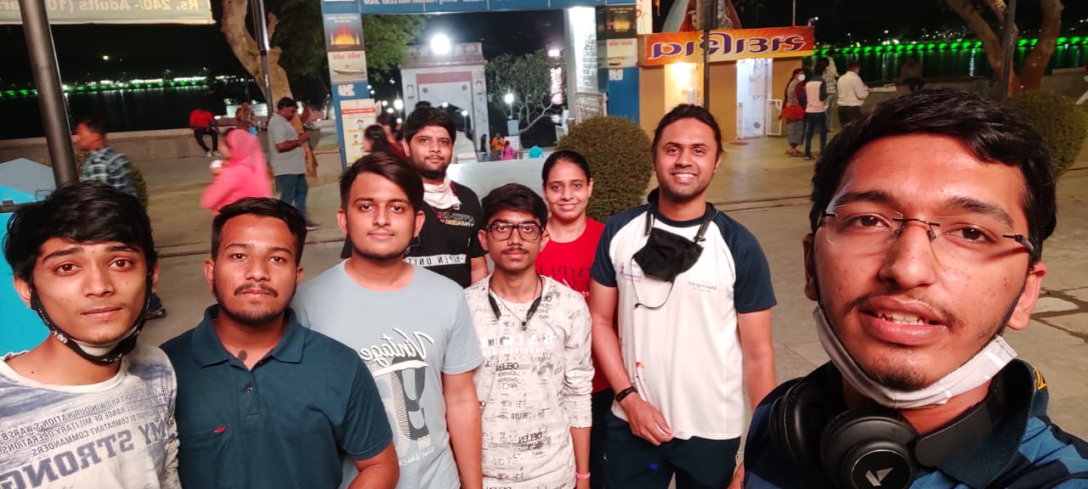 | 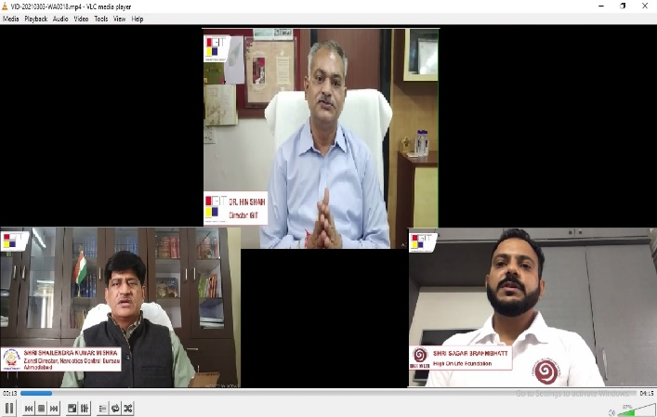
Faculty and student participants during the 5Km Run event at Kankaria Lake, Ahmedabad | Pre-event Video Campaign by Dr H N Shah, Shri Shailendra Kumar Mishra and Shri Sagar Brahmbhatt (Founder, High on Life Foundation)

